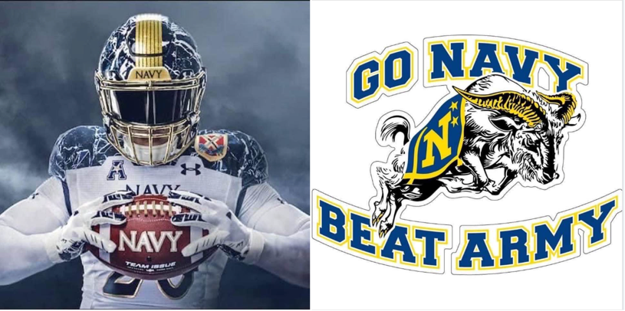

Bill Boniface '72 and Matt Chabal '77 in Hershey will be hosting the chapter’s 12th Annual Army-Navy football game watch party on December 9th at the Lancaster Brewing Company in Harrisburg. As those of you have attended in the past will attest, the brewing company has a nice bar with a good number of their own microbrews and a nice bar menu.

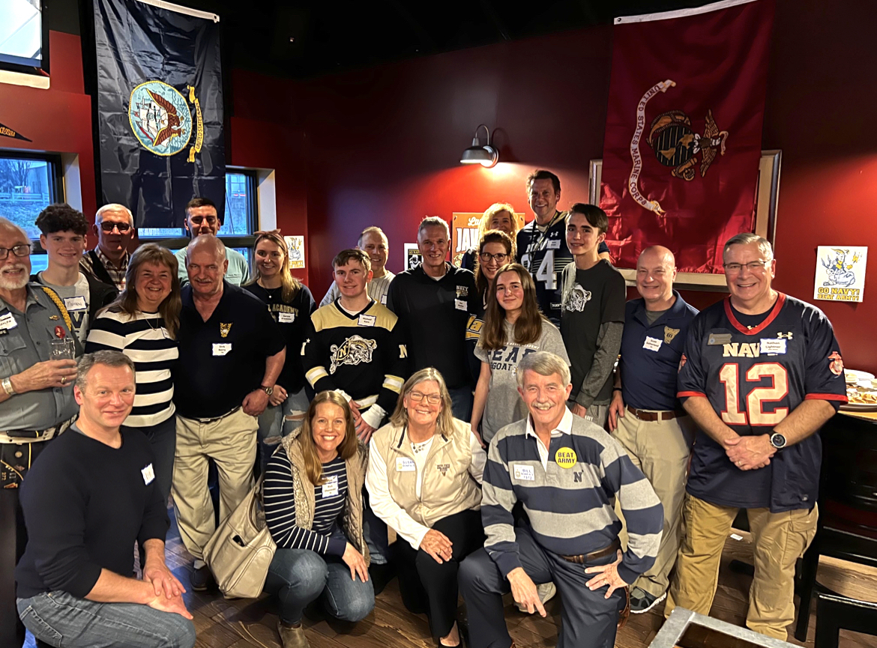

LBC is always enthusiastic about hosting chapter folks for an Army-Navy get-together (manager is a former Marine) and Bill and Matt have told them they'll see if they can get another good Central Pennsylvania USNA alumni turnout.

Kickoff is at 3:00, so they're planning to meet there at 2:00. It will be a cash bar and bar menu with a smattering of complimentary finger food and beer at the start (they also serve dinners in their dining area). More about the brewery can be found at their web site “lbcharrisburg.com” or on Facebook. Their address is 469 Eisenhower Blvd., Harrisburg 17111 near the Harrisburg Mall -- very easy to get to from Routes 322 or I-283/83.

Please respond to Bill Boniface at boniface72@gmail.com if you’ll be attending. They need a reasonably close count of alums and spouses (and families) a few days prior to the event in case LBC needs to lay on an additional bartender, so please RSVP to Bill by Saturday, December 2nd, if at all possible.

